Created by Jeff Hinton & Mike Wood - 2011

You can make some really fun games using PowerPoint 2010. Below is an example of how to make a simple PowerPoint Game.

Step 1: Set up slides 1, 4, and 5 as shown in the examples below.
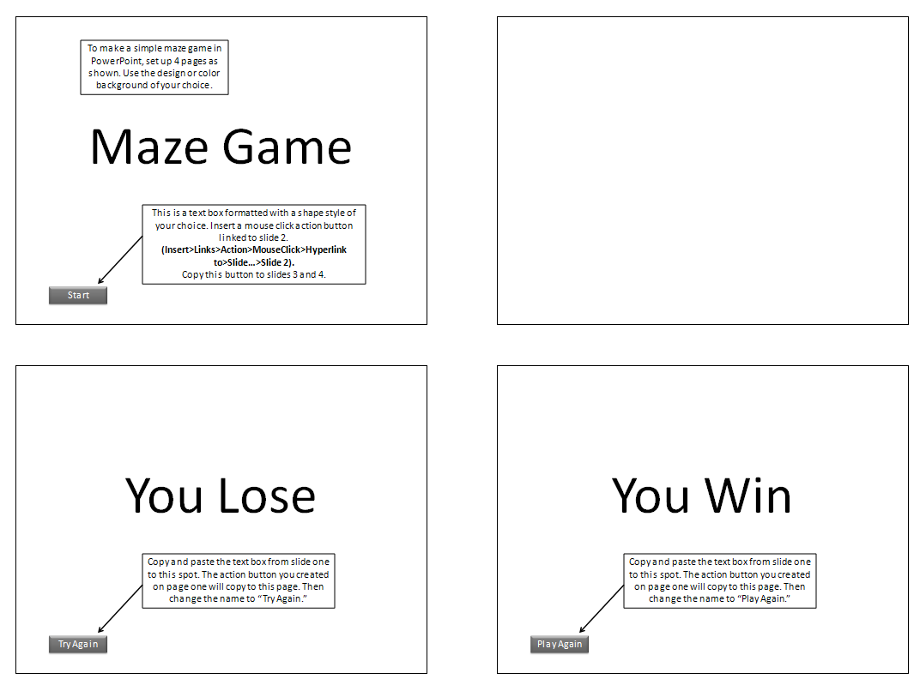

Step 2: Set up the action buttons as shown below to hyperlink to Slide 2. Make it on Mouse Click and play the “Chime” sound.
Step 3: On each slide, go to the Transitions Ribbon and uncheck the "on mouse click" box. (Transitions>Timing>Advance Slide). On Slide 2 only, check the “automatically after” box.
Step 4: Set up slide 3 as follows:

- Insert one rectangle shape (Insert>Illustrations>Shapes). Turn off the outline. (Drawing Tools>Format>Shape Styles>Shape Outline>No Outline)

- Insert a "Mouse Over" action to the shape you created (Insert>Links>Action Button) that hyperlinks to the "You Lose" slide (slide 3). Play the "bomb" sound.

- Now copy and paste that rectangle over and over again to the slide to create your maze as shown. Resize the rectangles as needed.

- Add the various shapes. Insert a ”Mouse Over” action button to the “pie” and “no” shapes that hyperlink to the “You Lose” slide. Set the action buttons to play the “bomb” sound.

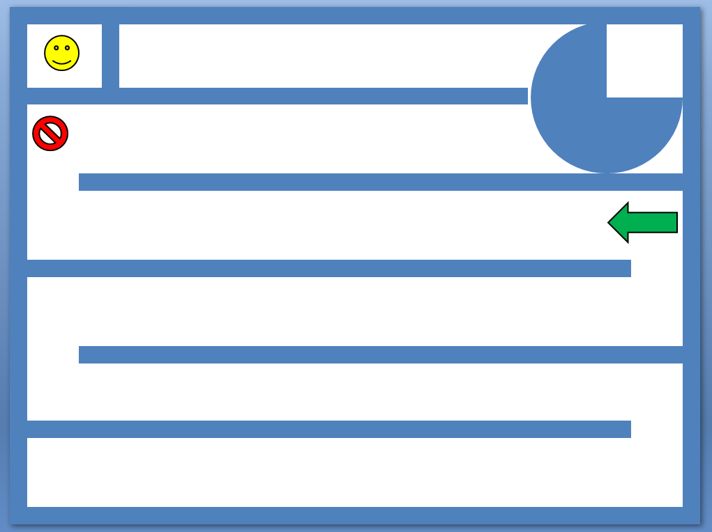

- Insert a mouse click action button to the smiley face that plays the applause sound and links to the “You Win” page.

- Select the rectangle blocking the way to the smiley face. Animate it to disappear. (Animations> Add Animation> Exit>Disappear). Add a trigger that starts effect on click of the arrow. (Animations>Advanced Animation>Animation Pane). See illustration for settings.

- Select the "no" symbol. Add custom animation that is a "down" motion path. (Animations> Add Animation> More Motion Paths>Down). Adjust the length of the path to extend up to the wall below it, but not beyond. Find the Effect Options in the Animation Pane by clicking on the down arrow next to the "No" Symbol. Set the effect options to auto-reverse and turn off smooth start and smooth end. Click on the "Timing" tab and set the animation to repeat "Until the End of Slide."
- Click on the "pie" shape. Add custom animation so that it spins. (Animations> Add Animation> More Emphasis Effects>Spin). Click on the "Timing" tab in the Effect Options and set the animation to repeat "Until End of Slide" like you did on the "no" symbol.

- Set all of the animations to “start with previous,” so they will begin when the slide begins. (See Illustration)

- Save and play the game.

